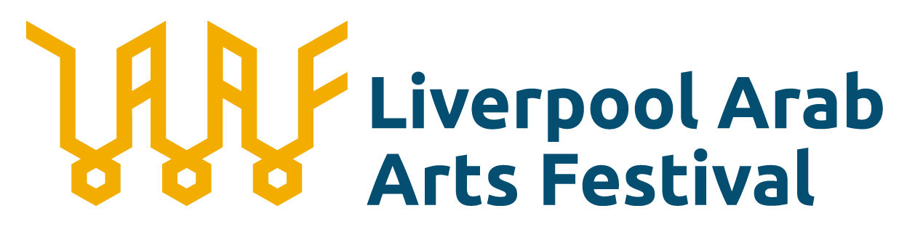

EQUAL OPPORTUNITIES MONITORING FORM

Why we’re asking for this data.

Liverpool Arab Arts Festival is committed to Equal Opportunities in our recruitment processes. The data we collect helps us to improve our future recruitment and hiring processes.

Any information that you provide will be strictly confidential and is anonymised.

If you do not know some of the information, or you would prefer not to provide it, you can fill in the 'Prefer not to answer' box.

Thank you.

Ethnicity:

Arab
White British
White Irish
Gypsy, Roma or Irish Traveller
Any other White background
White & Black Caribbean
White & Black African
White & Asian
Any other Mixed background
Indian
Pakistani
Bangladeshi
Chinese
Any other Asian background
Black African
Black Caribbean
Any other Black background
Latin American
Any other ethnic group
Prefer not to say

Age:

0-19
20-34
35-49
50-64
65-74
75+
Prefer not to say

Do you consider yourself to have a disability:

Yes - Identify as a deaf or disabled person, or have a long-term health condition
No
Prefer not to say

Which gender identity best represents you:

Female (including trans women)
Male (including trans men)
Non-Binary (e.g. androgyne)
Prefer not to say

Which gender best represents you:

Male
Female
Prefer to self-describe:
Prefer not to answer

What is your sexual orientation?

Bisexual
Gay Man
Gay Women / Lesbian
Heterosexual
Queer
Prefer to self-describe
Prefer not to say

Socio-Economic Background

Please enter the number of staff by occupation of the main/highest income earner in their household when they were 14.

Modern Professional Occupations
Clerical and Intermediate Occupations
Senior Managers and Administrators
Technical and Craft Occupations
Semi-Routine Manual and Service Occupations
Routine Manual and Service Occupations
Middle or Junior Managers
Traditional Professional Occupations
Short Term Unemployed
Long Term Unemployed
Retired
Not applicable
Don’t know
Prefer not to say

